**Check Atos Managed Tags applied to resources**

1. Login to portal (portal.azure.com)
2. Search any Virtual machine name in virtual machine.

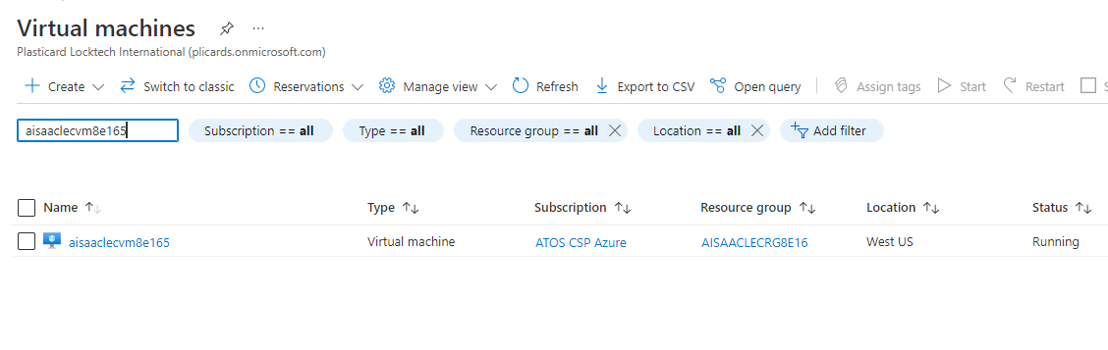

1. Select Virtual machine.

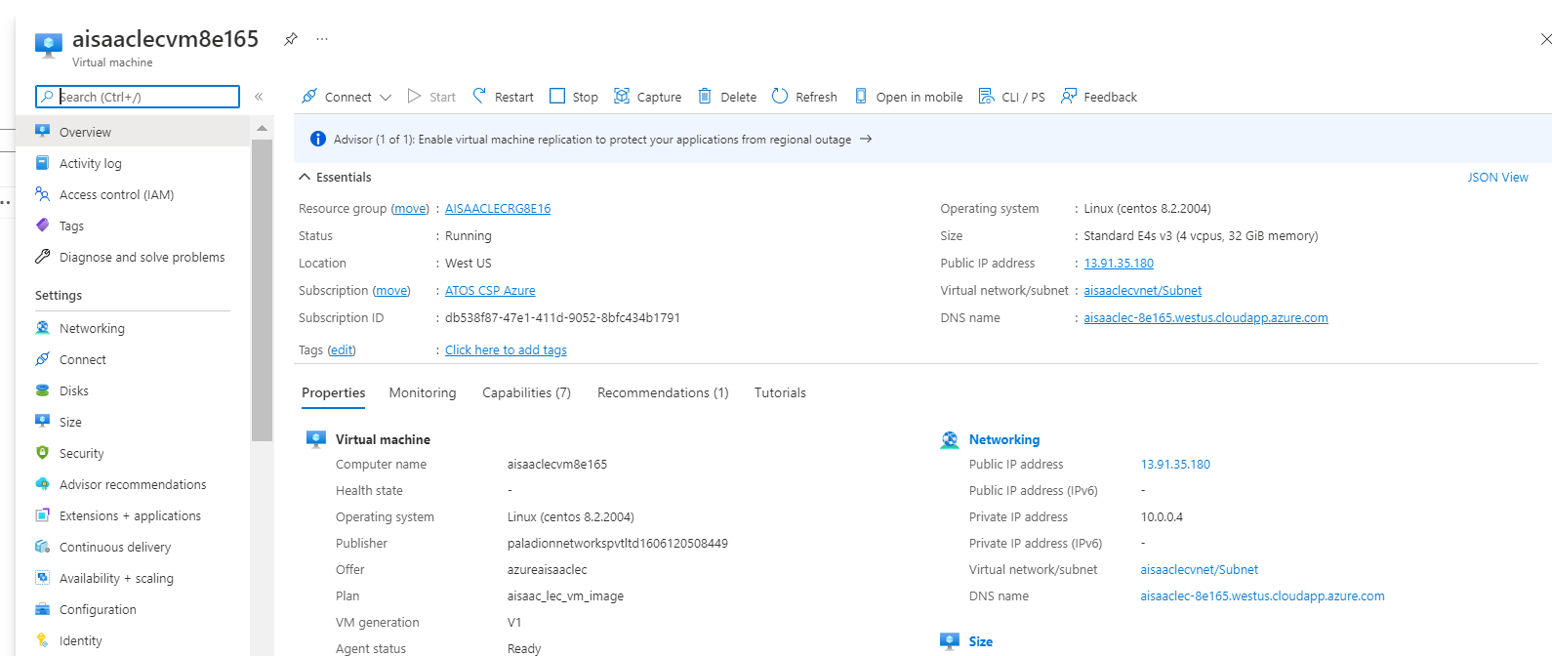

1. In blades, open tags and check whether VM has atos managed tag.

